Image | 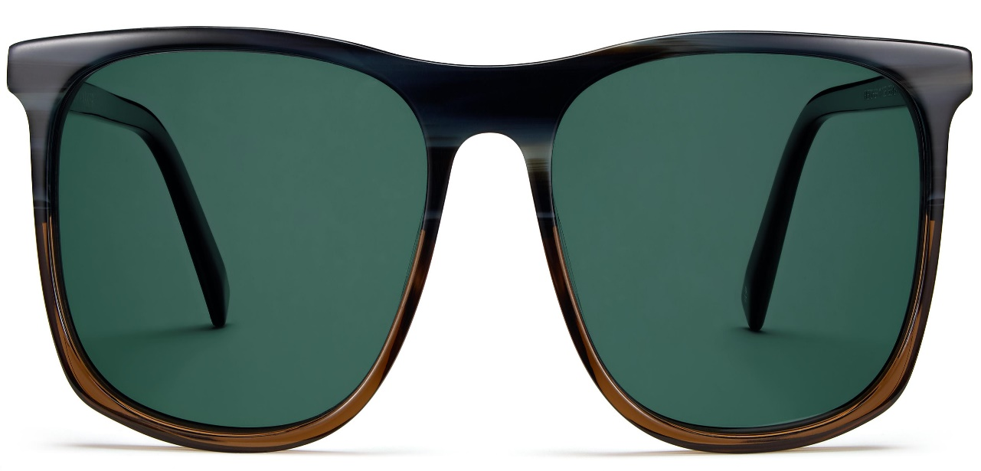
Brand | TOM FORD
Model Name | Fletcher
Price | RS 9599
PRODUCT DETAILS

